Program no: 01
Date: 30-07-2010

INTRODUCTION TO SOCKET PROGRAMMING

PROBLEM DEFINITION

To study the basics of socket programming.

THEORETICAL BACKGROUND

Sockets

The interaction between client and server is just like the interaction between a lamp and an electrical socket. The server is a permanently available resource, while the client is free to "unplug" after it is has been served. A socket is one end-point of a two-way communication link between two programs running on the network. Socket classes are used to represent the connection between a client program and a server program.

The java.net package provides two classes--Socket and ServerSocket--that implement the client side of the connection and the server side of the connection, respectively. A socket can be used to connect Java’s I/O system to other programs that may reside either on the local machine or on any other machine on the Internet.There are two kinds of TCP sockets in Java. One is for servers, and the other is for clients. The ServerSocket class is designed to be a “listener,” which waits for clients to connect before doing anything. The Socket class is designed to connect to server sockets and initiate protocol exchanges.

A server runs on a specific computer and has a socket that is bound to a specific port number. The server just waits, listening to the socket for a client to make a connection request. On the client-side: The client knows the hostname of the machine on which the server is running and the port number on which the server is listening. To make a connection request, the client tries to rendezvous with the server on the server's machine and port. The client also needs to identify itself to the server so it binds to a local port number that it will use during this connection. This is usually assigned by the system.

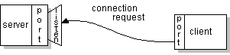

If everything goes well, the server accepts the connection. Upon acceptance, the server gets a new socket bound to the same local port and also has its remote endpoint set to the address and port of the client. It needs a new socket so that it can continue to listen to the original socket for connection requests while tending to the needs of the connected client.
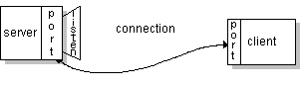

On the client side, if the connection is accepted, a socket is successfully created and the client can use the socket to communicate with the server. The client and server can now communicate by writing to or reading from their sockets.
Socket Class
The Socket class provides a rich set of methods and properties for network communications. The Socket class allows you to perform both synchronous and asynchronous data transfer using any of the communication protocols listed in the ProtocolType enumeration. The Socket class follows the .NET Framework naming pattern for asynchronous methods.
If your application only requires one thread during execution, use the following methods, which are designed for synchronous operation mode.
- If you are using a connection-oriented protocol such as TCP, your server can listen for connections using the Listen method. The Accept method processes any incoming connection requests and returns a Socket that you can use to communicate data with the remote host. Use this returned Socket to call the Send or Receive method. Call the Bind method prior to calling the Listen method if you want to specify the local IP address and port number. Use a port number of zero if you want the underlying service provider to assign a free port for you. If you want to connect to a listening host, call the Connect method. To communicate data, call the Send or Receive method.
- If you are using a connectionless protocol such as UDP, you do not need to listen for connections at all. Call the ReceiveFrom method to accept any incoming datagrams. Use the SendTo method to send datagrams to a remote host.

Socket Class Constructors
Here are two constructors used to create client sockets:

Socket(String hostName, int port)

Creates a socket connecting the local host to the named host and port; can throw an UnknownHostException or an IOException.

Socket(InetAddress ipAddress, int port)

Creates a socket using a preexisting InetAddress object and a port; can throw an IOException. A socket can be examined at any time for the address and port information
associated with it, by use of the following methods: InetAddress getInetAddress( ) Returns the InetAddress associated with the Socket object.

int getPort( )
Returns the remote port to which this Socket object is connected.

int getLocalPort( )
Returns the local port to which this Socket object is connected.

Reading input and writing output to a socket

Once the Socket object has been created, it can also be examined to gain access to
the input and output streams associated with it. Each of these methods can throw an
IOException if the sockets have been invalidated by a loss of connection on the Net.

InputStream getInputStream( )
Returns the InputStream associated with the invoking socket.

OutputStream getOutputStream( )
Returns the OutputStream associated with the invoking socket.
THE JAVA LIBRARY
getChannel( ) method:
This method returns a channel connected to the Socket object. Channels are used by the new I/O classes contained in java.nio.

ServerSocket

The ServerSocket class is designed to be a "listener," which waits for clients to connect before doing anything.

Reading Data with a ServerSocket
The port scanner pretty much exhausts what you can do with just the constructors. Almost all ServerSocket objects you create will use their accept() method to connect to a client.
public Socket accept() throws IOException
There are no getInputStream() or getOutputStream() methods for ServerSocket. Instead you use accept() to return a Socket object, and then call its getInputStream() or getOutputStream() methods.

For example,
try {
ServerSocket ss = new ServerSocket(2345);
Socket s = ss.accept();
PrintWriter pw = new PrintWriter(s.getOutputStream());
pw.println("Hello There!");
pw.println("Goodbye now.);
s.close();
}
catch (IOException ex) {
System.err.println(ex);
}

CONCLUSION

The concepts in socket programming in java were studied and familiarised

Program no: 02
Date: 30-07-2010

INTRODUCTION TO MULTITHREADING

PROBLEM DEFINITION

To study the threads in JAVA and its implementation

THEORETICAL BACKGROUND

Java provides built-in support for multithreaded programming. Multithreading enables you to write very efficient programs that make maximum use of the CPU, because idle time can be kept to a minimum. This is especially important for the interactive, networked environment in which Java operates, because idle time is common. A multithreaded program contains two or more parts that can run concurrently. Each part of such a program is called a thread, and each thread defines a separate path of execution. Thus, multithreading is a specialized form of multitasking.

THREADS IN JAVA:

The thread is the smallest unit of dispatchable code. Because a program can contain more than one thread, a single program can use multiple threads to perform two or more tasks at once. For instance, a browser can begin rendering a Web page while it is still downloading the remainder of the page. This is possible because each action is performed by a separate thread.

Multithreading is a technique that allows a program or a process to execute many tasks concurrently (at the same time and parallel). It allows a process to run its tasks in parallel mode on a single processor system. In the multithreading concept, several multiple lightweight processes are run in a single process/task or program by a single processor.

In Java, the Java Virtual Machine (JVM) allows an application to have multiple threads of execution running concurrently. It allows a program to be more responsible to the user. When a program contains multiple threads then the CPU can switch between the two threads to execute them at the same time. For example, look at the diagram shown as:
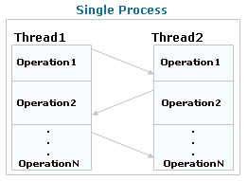
In this diagram, two threads are being executed having more than one task. The task of each thread is switched to the task of another thread.
Advantages of multithreading over multitasking :
- Reduces the computation time.
- Improves performance of an application.
- Threads share the same address space so it saves the memory.
- Context switching between threads is usually less expensive than between processes.
- Cost of communication between threads is relatively low.

JAVA THREAD MODEL
The Java run-time system depends on threads for many things, and all the class libraries
are designed with multithreading in mind. In fact, Java uses threads to enable the entire
environment to be asynchronous. This helps reduce inefficiency by preventing the waste
of CPU cycles.
At a point of time a thread can be in any one of the following states – new, ready, running, inactive and finished. A thread enters the new state as soon as it is created. When it is started (by invoking start() method), it is ready to run. The start() method in turn calls the run() method which makes the thread enter the running state. While running, a thread might get blocked because some resource that it requires is not available, or it could be suspended on purpose for some reason (like put off to sleep by the programmer). In such a case the thread enters the state of being inactive. A thread can also be stopped purposely because its time has expired, then it enters the state of ready to run once again.
A thread that is in running state can be stopped once its job has finished. A thread that is ready to run can also be stopped. A thread that is stopped enters the finished state. A thread that is in inactive state can either be resumed, in which case it enters the ready state again, or it can be stopped in which case it enters the finished state.

Thread Priorities

In multithreading environment, one thread might require the attention of the CPU more quickly than other. In such a case that thread is said to be of high priority. Priority of a thread determines the switching from one thread to another. In other words, priority determines how a thread should behave with respect to the other threads.
The word priority should not be confused with the faster running of a thread. A high priority thread does not run any faster than the low priority thread. A thread can voluntarily leave the control by explicitly stopping, sleeping or blocking on pending I/O or it can pre-empted by the system to do so. In the first case the processor examines all threads and assigns the control to the thread having the highest priority. In the second case, a low priority thread that is not ready to leave the control is simply pre-empted by the higher priority thread no matter what it is doing. This is known as pre-emptive multi-tasking. It is advisable that in case two threads have the same priority, they must explicitly surrender the control to their peers.

Synchronization

Multithreading produces asynchronous behavior among the programs. This means that all threads run as independent units without affecting each other. But sometimes it becomes necessary to synchronize these threads. For example, synchronization must be provided when two threads share the same variable or data structure like an array. In such a case there must be way by which they should not come in each other’s way.

Messaging

Since there are more than one thread in a multithreaded environment, inter-process communication becomes imperative. A thread should be able to communicate with the other threads. Threads can talk to each other by using method such as wait().

IMPLEMENTING JAVA THREAD

We can create a thread in Java by extending Thread Class. A better way to create a thread in Java is to implement Runnable interface. A thread can be created by extending Java Thread class also.If the thread class you are creating is to be subclass of some other class, it can’t extend from the Thread class. This is because Java does not allow a class to inherit from more than one class. In such a case one can use Runnable interface to implement threads.

Threads are implemented in the form of objects that contain a method called run(). It makes up the entirs body of a thread and is the only method in which the threads’ behaviour can be implemented.

Public void run()
{
………………..(statements for implementing thread)
………………..
}

Starting a new thread:

To actually create and run an instance of our thread class, we must write the following

ThreadTest th= new ThreadTest(); //new born state
th.start(); //invokes run() method i.e.,runnable state

CONCLUSION

The concepts of multithreading and its implementation were studied and familiarized.

Experiment No:3
Date: 04-07-2010

CLIENT-SERVER UNIDIRECTIONAL COMMUNICATION

PROBLEM DEFINITION:

To develop a java networking program for client- server unidirectional communication.

THEORETICAL BACKGROUND:

TCP (Transmission Control Protocol) is a connection-based protocol that provides a reliable flow of data between two computers.When two applications want to communicate to each other reliably, they establish a connection and send data back and forth over that connection. This is analogous to making a telephone call. If you want to speak to A, a connection is established when you dial her phone number and she answers. You send data back and forth over the connection by speaking to one another over the phone lines. TCP guarantees that data sent from one end of the connection actually gets to the other end and in the same order it was sent. Otherwise, an error is reported.

TCP provides a point-to-point channel for applications that require reliable communications. The Hypertext Transfer Protocol (HTTP), File Transfer Protocol (FTP), and Telnet are all examples of applications that require a reliable communication channel. The order in which the data is sent and received over the network is critical to the success of these applications. When HTTP is used to read from a URL, the data must be received in the order in which it was sent. Otherwise, you end up with a jumbled HTML file, a corrupt zip file, or some other invalid information.
Connection is accomplished through the constructors in the server program and in the client program. Each “Socket” object is associated with exactly one remote host. To connect to a different host, another new “Socket” object must be created.The java.net.ServerSocket class represents a server socket.A ServerSocket object is constructed on a particular local port. Then it calls accept() to listen for incoming connections. accept() blocks until a connection is detected. Then accept() returns a java.net.Socket object that performs the actual communication with the client.

Constructors of client program :-
public Socket(String host, int port) throws UnknownHostException, IOException
public Socket(InetAddress address, int port) throws IOException

Constructors of server program:-
public ServerSocket(int port) throws IOException
public ServerSocket(int port, int backlog) throws IOException
The accept() and close() methods provide the basic functionality of a server socket.
public Socket accept() throws IOException
public void close() throws IOException

PSEUDOCODE:

Server

Step 1: Start the Server
Step 2: Create Server Socket in port 3000
Step 3: Create socket and bind the server socket to it.
Step 4: Create Buffer to Input string from client
Step 5: Repeat steps 6 to 7 until user break the program
Step 6: Accept the string from the buffer created
Step 7: Print the screen
Step 8: Stop

Client

Step 1: Start
Step 2: Create Socket with server IP and port 3000
Step 3: Create buffer to input the string from the user
Step 4: Create print writer to write the string to server
Step 5: Repeat steps 6 to 7 until user breaks the program
Step 6: Input string from the user
Step 7: Send this string to server
Step 8: Stop

PROGRAM DEVELOPMENT:
Server.java
import java.io.*;
import java.net.*;

class server
{

public static void main(String args[]) throws IOException
{
try {

System.out.println("Entered");
ServerSocket ss = new ServerSocket(3000);
System.out.println(ss);
Socket s=ss.accept();

BufferedReader b=new BufferedReader(new InputStreamReader(s.getInputStream()));
String str=b.readLine();

System.out.println("From Client: " +str);
ss.close();

s.close();
}

catch(Exception e)
{
System.out.println(e);
}

}
}

Client.java

import java.net.*;
import java.io.*;
class client {

public static void main(String args[])throws IOException
{

try
{
Socket s=new Socket("LocalHost",3000);
BufferedReader b=new BufferedReader(new InputStreamReader(System.in));

String str=b.readLine();

PrintWriter pw=new PrintWriter (s.getOutputStream(),true);

pw.println(str);

s.close();

}

catch(IOException e)
{
System.out.println("Error..."+e);
}
}

}

TESTING STRATEGIES:

Test case 1:
Client sending data to server.
Server sending data to client.

Test case 2:
Server not started, client requesting for connection with server.

SUMMARY OF RESULTS:

Case 1:
Client sending data to
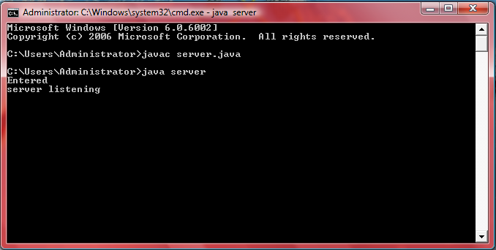

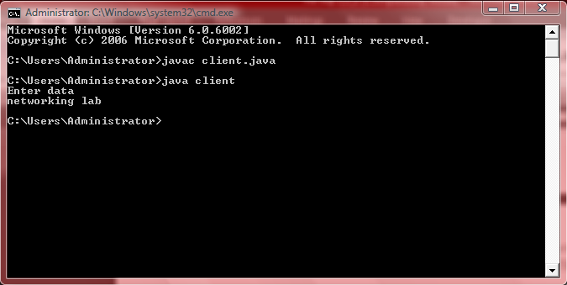

Server receiving data from client.

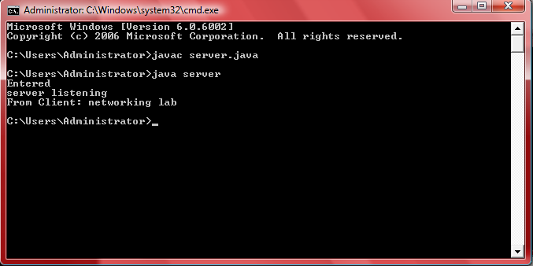

Case 2:
Server not up, client requesting for connection with server.

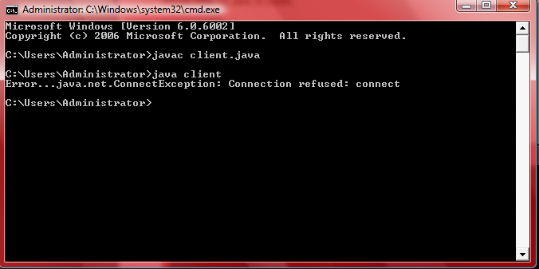

CONCLUSION:
Client-server unidirectional communication successfully implemented.

Program no: 4
Date: 04-08-2010

ECHOSERVER

PROBLEM DEFINITION

To develop a java networking program to echo the data sent by the client to the server.

THEORETICAL BACKGROUND

The interaction between client and server is just like the interaction between a lamp and an electrical socket. The server is a permanently available resource, while the client is free to "unplug" after it is has been served. A socket is one end-point of a two-way communication link between two programs running on the network. Socket classes are used to represent the connection between a client program and a server program.

The java.net package provides two classes--Socket and ServerSocket--that implement the client side of the connection and the server side of the connection, respectively. A socket can be used to connect Java’s I/O system to other programs that may reside either on the local machine or on any other machine on the Internet.There are two kinds of TCP sockets in Java. One is for servers, and the other is for clients. The ServerSocket class is designed to be a “listener,” which waits for clients to connect before doing anything. The Socket class is designed to connect to server sockets and initiate protocol exchanges.

TCP is known as a connection-oriented protocol, which means that a connection is established and maintained until such time as the message or messages to be exchanged by the application programs at each end have been exchanged. TCP is responsible for ensuring that a message is divided into the packets that IP manages and for reassembling the packets back into the complete message at the other end. In the Open Systems Interconnection (OSI) communication model, TCP is in layer 4, the Transport Layer.
TCP networking in Java is accomplished by using the Socket and ServerSocket classes. For a Java network to be set up there must be a server and a client program running. The sample Client and Server classes shown below is a simple example showing how to send two int-values from the client to the server performing a computation on the numbers within the server program and then sending it back to the client program. For a TCP bi-directional communication following steps should be performed in the application side. In this program we have the client side accepting the user input & forward it to the server. On receiving it the server echoes the message back to the client.

ALGORITHM

Client

Step 1: Start the client
Step 2: Create Socket with server IP and port 3040
Step 3: Create buffer to input the string from the user
Step 4: Create print writer to write the string to server
Step 5: Aceept the echo data from the server
Step 6: Print the echo data from the server
Step 7: Stop

Server

Step 1: Start the Server
Step 2: Create Server Socket in port 3040
Step 3: Create socket and bind the server socket to it.
Step 4: Create Buffer to Input string from client
Step 5: Print the client string.
Step 6: Create print writer to write the string to client
Step 7: Stop

PROGRAM DEVELOPMENT

Client side

import java.io.*;
import java.net.*;
class client
{
public static void main(String args[]) throws IOException
{
String str;
do
{
Socket s=new Socket("localhost",3040);
System.out.println("Enter the input");
BufferedReader br1 =new BufferedReader(new InputStreamReader(System.in));
str=br1.readLine();
PrintWriter pw=new PrintWriter(s.getOutputStream(),true);
pw.println(str);
BufferedReader br2=new BufferedReader(new InputStreamReader(s.getInputStream()));
str=br2.readLine();
System.out.println("Echo from the server"+str);

s.close();
}while(!str.equals("exit"));
}
}

Server Side

import java.io.*;
import java.net.*;
class server
{
public static void main(String args[]) throws IOException
{
String str;
System.out.println("waiting for client");
do
{
ServerSocket ss=new ServerSocket(3040);
Socket s=ss.accept();

BufferedReader br=new BufferedReader(new InputStreamReader(s.getInputStream()));
str=br.readLine();
System.out.println("Message from Client Side: "+str);
PrintWriter pw=new PrintWriter(s.getOutputStream(),true);
pw.println(str);

s.close();
ss.close();
}while(!str.equals("exit"));
}
}

TESTING STRATEGIES

Test case 1:

Client:

Anila
Paul
Raset
exit

SUMMARY OF RESULTS

Case 1:

Server

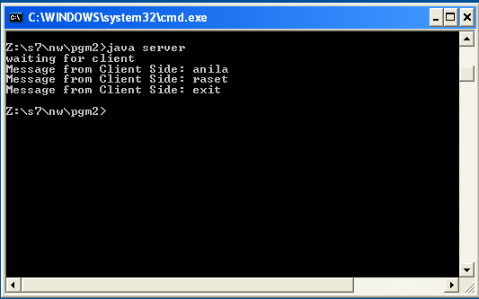

client

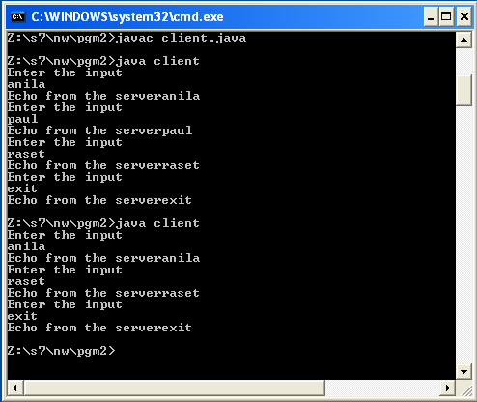

CONCLUSION

The aim was to develop a java networking program to echo the data sent by the client to the server. This was implemented successfully

Experiment No: 5
Date:14/09/2010

BI-DIRECTIONAL CLIENT-SERVER PROGRAM

PROBLEM DEFINITION

The aim is to write a program to perform bi directional client-server program without using threads.

THEORETICAL BACKGROUND

Client-server computing or networking is a distributed application architecture that partitions tasks or workloads between service providers (servers) and service requesters, called clients. Often clients and servers operate over a computer network on separate hardware. A server machine is a high-performance host that is running one or more server programs which share its resources with clients. A client does not share any of its resources, but requests a server's content or service function. Clients therefore initiate communication sessions with servers which await (listen to) incoming requests.

A bidirectional client server program is one in which client and server can sent data both sides bidirectionaly.
Client-server describes the relationship between two computer programs in which one program, the client program, makes a service request to another, the server program. Standard networked functions such as email exchange, web access and database access, are based on the client-server model. For example, a web browser is a client program at the user computer that may access information at any web server in the world. To check your bank account from your computer, a web browser client program in your computer forwards your request to a web server program at the bank. That program may in turn forward the request to its own database client program that sends a request to a database server at another bank computer to retrieve your account balance. The balance is returned to the bank database client, which in turn serves it back to the web browser client in your personal computer, which displays the information for you.
A socket is one endpoint of a two-way communication link between two programs running on the network. A socket is bound to a port number so that the TCP layer can identify the application that data is destined to be sent

ALGORITHM

Server side

- Start.
- Create a server socket on port 4444
ServerSocket s=new ServerSocket(port number);
- Accept client request into socket.
Socket c=s.accept()
- Read the buffered reader to read the input and print it to the monitor using print writer.
BufferedReader R=new BufferedReader(new InputStreamReader(c.getInputStream()));
PrintWriter P=new PrintWriter(c.getOutputStream(),true)
- Using another buffered reader read data from keyboard and print it to the output stream
BufferedReader R1=new BufferedReader(new InputStreamReader(System.in))
P.println(c1)
- Close the connection.
s.close()
- Stop.

Client side

- Start
- Create a socket targeting localhost and port 4444.
Socket s=new Socket("localhost", port number)
- Buffered reader is used to read keyboard.
BufferedReader R=new BufferedReader(new InputStreamReader(System.in))
- Read a line from buffer.
c1 = R.readLine()
- Use print writer to send the data via network.
PrintWriter P=new PrintWriter(s.getOutputStream(),true)
- Close socket.
- s.close()
- Stop

PROGRAM DEVELOPMENT

Server Side

/*Server side - Bidirectional*/

import java.io.*;
import java.net.*;
public class Server2
{
public static void main(String args[]) throws IOException
{
Socket c;
String str;
ServerSocket s=new ServerSocket(5555);
c=s.accept();
BufferedReader R1= new BufferedReader(new InputStreamReader(c.getInputStream()));
BufferedReader R2= new BufferedReader(new InputStreamReader(System.in));
PrintWriter P=new PrintWriter(c.getOutputStream(),true);
do
{
/*From client*/
str=R1.readLine();
System.out.println("Client : "+str);
/*To client*/
System.out.print("Enter line (\"exit\" to quit) : ");
str=R2.readLine();
P.println(str);
}while(!str.equals("exit"));
}
}

Client Side

import java.io.*;

import java.net.*;

public class Client2

{

public static void main(String args[]) throws IOException

{

Socket s=new Socket("localhost",5555);

String str;

BufferedReader R1=new BufferedReader(new InputStreamReader(System.in));

PrintWriter P=new PrintWriter(s.getOutputStream(),true);

BufferedReader R2= new BufferedReader(new InputStreamReader(s.getInputStream()));

do

{

/*To server*/

System.out.print("Enter line (\"exit\" to quit) : ");

str=R1.readLine();

P.println(str);

/*From server*/

str=R2.readLine();

System.out.println("Server : " +str);

}while(!str.equals("exit"));

s.close();

}

}

TESTING STRATEGIES AND SUMMARY OF RESULTS

Case 1

Running the client & entering the message:

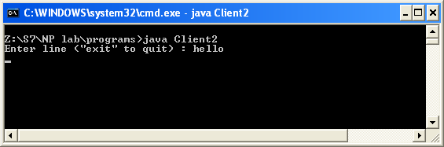

Receiving the message from the client & entering the message from the server:

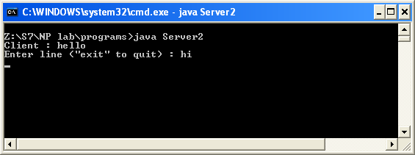

Receiving the message from the server & entering the message from the client:

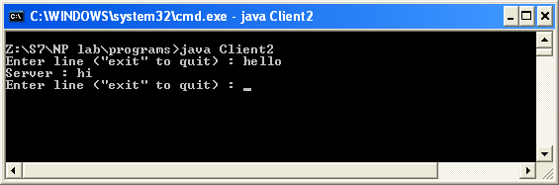

Exiting from the client:

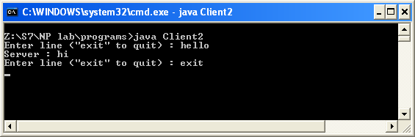

Server receives the exit message:

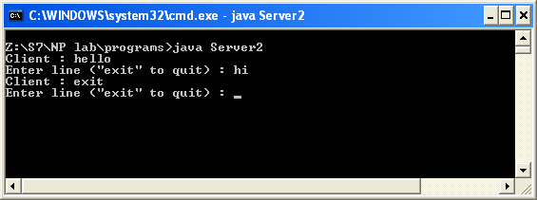

Exiting from the server:

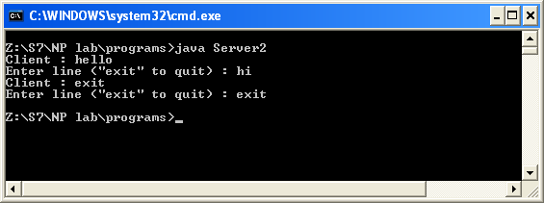

Exited from the client:

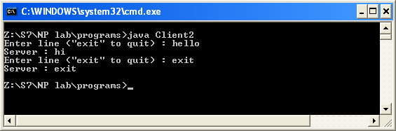

CONCLUSION

The program was to perform bi directional client to server program. Algorithm was written. Code was generated, test cases were given and output was verified.

Program No: 6
Date:14/09/10

BIDIRECTIONAL COMMUNICATION USING THREADS

PROBLEM DEFINITION

To develop a java networking program for client and server and to implement a bidirectional communication between client and server using threads.

THEORETICAL BACKGROUND

The interaction between client and server is just like the interaction between a lamp and an electrical socket. The server is a permanently available resource, while the client is free to "unplug" after it is has been served. A socket is one end-point of a two-way communication link between two programs running on the network. Socket classes are used to represent the connection between a client program and a server program.

Java supports advanced programming concepts such as threads. A thread is a process that can run concurrently with other processes. Java is inherently multi-threaded. A single Java program can have many different threads executing independently and continuously. Three Java applets on the same page can run together with each getting equal time from the CPU with very little extra effort on the part of the programmer. This makes Java very responsive to user input. It also helps to contribute to Java's robustness. It also ensures that a malicious applet doesn’t steal all of the host's CPU cycles.

Socket (String host, int port) throws IOException

- This creates a Socket and connects to the specified host and port. Host can be a host name or IP address and port must be in a range of 1-65535.

Socket (InetAddress address, int port) throws IOException

- This creates a Socket and connects to the specified port of the host address. The port must be in a range of 1-65535.
- These methods allow the remote host address and local or remote port numbers to be identified. These methods also allow for the creation of input and output streams.

ALGORITHM

Server

Step 1: Start the server
Step 2: Create Socket with server IP and port 3110
Step 3: Create socket and bind the server socket to it.
Step4: Create two threads t1 and t2
Step 4: Create Buffer to Input string from client
Step 5: Accept the string from the buffer created & print it
Step 6: Input string from the user
Step 7: Send the user inputted string to the client.
Step 8: Stop

Client

Step 1: Start the Client
Step 2: Create Socket in port 3110
Step 3: Create buffer to input the string from the user
Step 5: Create two threads for reading and writing simultaneously.
Step 4: Send the string to the server.
Step 5: Accept the string from the client & Print it
Step 6: Stop

PROGRAM DEVELOPMENT

Client side

import java.net.*;
import java.io.*;

class client implements Runnable
{
Socket s;
ServerSocket ss;
BufferedReader br1,br2;
PrintWriter pw1,pw2;
Thread t1,t2;
String str1,str2;
client()
{
try
{
s=new Socket("localhost",3040);
System.out.println("connected to server");
t1=new Thread(this);
t2=new Thread(this);
t1.start();
t2.start();
}
catch (Exception e)
{
}
}

public void run()
{
while(true)
{
try
{
if(Thread.currentThread()==t1)
{

br1=newBufferedReader(new InputStreamReader(System.in));
str1=br1.readLine();
pw1=new PrintWriter(s.getOutputStream(),true);
pw1.println(str1);
}
else
if (Thread.currentThread()==t2)
{

br2=newBufferedReader(new InputStreamReader(s.getInputStream()));
str2=br2.readLine();

pw2=new PrintWriter(System.out,true);
pw2.println(str2);
}
}
catch(Exception e)
{
}

}
}
public static void main (String args[])
{
client obj= new client();
}
}

Server Side

import java.io.*;
import java.net.*;

class server implements Runnable
{
Socket s;
ServerSocket ss;
BufferedReader br1,br2;

PrintWriter pw1,pw2;
Thread t1,t2;
String str1,str2;

server()
{
try
{
System.out.println("waiting for client");
ss= new ServerSocket(3040);
s=ss.accept();
System.out.println("client connected");

t1=new Thread(this);
t2=new Thread(this);
t1.start();
t2.start();
}
catch(Exception e)
{
}
}
public void run()
{
while(true)
{
try
{
if(Thread.currentThread()==t1)
{

br1=newBufferedReader(new InputStreamReader(s.getInputStream()));
str1=br1.readLine();

pw1=new PrintWriter(System.out,true);
pw1.println(str1);
}
else
if(Thread.currentThread()==t2)
{

br2=newBufferedReader(new InputStreamReader(System.in));

pw2=new PrintWriter(s.getOutputStream(),true);
pw2.println(br2.readLine());
}
}
catch(Exception e)
{
}
}
}
public static void main(String args[]) throws IOException
{
server obj=new server();
}
}

TESTING STRATEGIES:
Test case 1:
Client sending data to server and server sending data to client,client stops and server continues.
Test case 2:
Client sending data to server and server sending data to client,server stops stopping the client.

SUMMARY OF RESULTS:
Case 1:
Client sending data to server and server sending data to client,client stops and server continues.

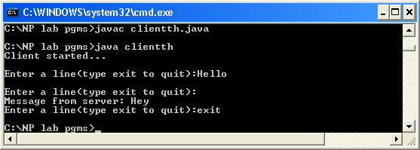

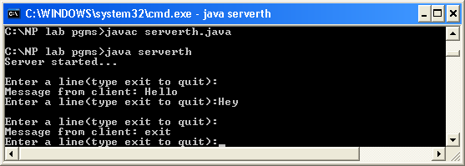

Case 2:
Client sending data to server and server sending data to client,server stops stopping the client.

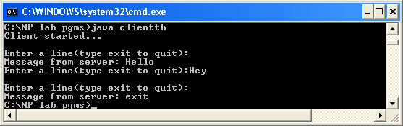

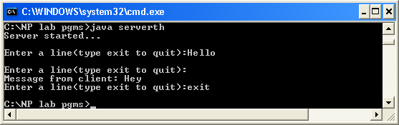

CONCLUSION

The java networking program of client and server for implementing a bidirectional communication between client and server using threads was developed successfully. Algorithm was made and then the program was coded. Various test cases were given and the required results were obtained.

Program No:7
Date:08/09/10

BROADCASTING MESSAGES

PROBLEM DEFINITION

Program to implement message broadcasting from server to clients using sockets and datagram.

THEORETICAL BACKGROUND

Broadcasting and Multicast Protocol

Broadcasting means sending data freely, for all receivers listening to receive the data simultaneously. Also called multicasting, it sends data from one host to many different hosts, the data goes only to clients that have expressed an interest in the data by joining particular multicast group. It needs a special protocol called Multicast protocol. With a multicast transport service a single node can send data to many destinations by making just a single call on the transport service.

Multicasting makes use of the UDP (User Datagram Protocol), which is an unreliable but high transmission speed protocol. Multicasting also uses special IP addresses in the range 224.0.0.0 - 239.255.255.255.

Datagram

A datagram is an independent, self-contained message sent over the network whose arrival, arrival time, and content are not guaranteed.

Clients and servers that communicate via a perfect channel have a dedicated point-to-point channel between themselves. To communicate, they must first establish the connection, transmit the data, and then close down the connection. All data sent over the channel is received in the same order that it was sent. This is guaranteed by the channel.

In contrast, clients and servers that communicate via datagrams send and receive completely independent packets. These clients and servers do not have a dedicated point-to-point channel. Rather the packets are sent on their way over the network on whatever route is available. A packet sent over a perfect channel does not contain any information about its source or its destination. The channel contains that information. In contrast, a datagram packet must contain the complete address of its source or destination depending on if the datagram is sent or received.
The java.net package contains two classes that use the datagram model to send and recieve packets over the network: DatagramSocket and DatagramPacket. A DatagramSocket is a communcation link used to send datagrams between applications. A DatagramPacket is a message sent between applications via a DatagramSocket.

The DatagramPacket Class

This class is used to create the datagram packets for transmission and receipt with data and address information.

Constructors and Methods

DatagramPacket(byte inbuf[], int buflength)

This statement constructs a datagram packet for receiving datagrams. Inbuff is a byte array that holds the data received and buflength is the maximum number of bytes to read. We are effectively ignoring the address and port information held within the packet

DatagramPacket(byte inbuf[], int buflength, InetAddress iaddr, int port)

This statement constructs a datagram packet for transmission. As above inbuff holds the data to be sent, buflength is the amount of data to be sent, iaddr is the address of the destination and port is the port number on the remote host.

InetAddress getAddress()

This method returns the IP address of the packet source or destination. If the datagram was received from the Internet the address returned is the address of the machine that sent it (source address). Otherwise if datagram was created locally to be sent to a remote host, then address returned is the address of the remote machine to which the datagram is addressed. This method is commonly used to determine the address of the host that sent a UDP datagram, so that the recipient can reply.

The DatagramSocket Class

The DatagramSocket class is used to create sockets through which the DatagramPackets are send and received. As with TCP, a UDP DatagramSocket must listen on a port number.

Constructors and Methods

DatagramSocket() throws SocketException

A DatagramSocket is created using the next available free port number.

DatagramSocket(int port) throws SocketException

A DatagramSocket is created using the specified port number.

void send(DatagramPacket p) throws IOException

This method sends the packet out onto the network.

syncronized void receive(DatagramPacket p) throws IOException

This method receives a packet into the specified DatagramPacket. This method blocks until a packet has been received successfully.

MulticastSocket is a subclass of DatagramSocket which has the extended ability to join and leave multicast groups. A multicast group consists of both a multicast address and a port number. The only difference between UDP and multicast in this respect is that multicast groups are represented by Class D internet addresses. Just as there are well-known ports for network services, there are reserved, well-known multicast groups for multicast network services.

When an application subscribes to a multicast group (host/port), it receives datagrams sent by other hosts to that group, as do all other members of the group. Multiple applications may subscribe to a multicast group and port concurrently, and they will all receive group datagrams. When an application sends a message to a multicast group, all subscribing recipients to that host and port receive the message. The application needn't be a member of the multicast group to send messages to it.

ALGORITHM

Server

1. Start.
2. Create the object of server class that implements the Runnable interface.
3. Create a server socket at a port number 5739.
4. Create a client socket and accept the request from the client.
5. Create a two threads named key and str.
6. Start the two threads.
7. If the current thread in execution is key, then go to step 8, else go to step 12.
8. Read the data inputted from keyboard.
9. Store the data from buffer into a string.
10. Send the input data through the output stream to the client.
11. Repeat steps 8 to 10 until the data input is stop.
12. Read the data send from client side from the input stream.
13. Store the data from buffer into a string.
14. Print the data received from client.
15. Repeat steps 12 to 14 until the data input is stop.
16. Close the server socket.
17. Close the client socket.
18. Stop.

Client

1. Start.
2. Create the object of client class that implements the Runnable interface.
3. Create a client socket at a port number 5739.
4. Create a two threads named key and str.
5. Start the two threads.
6. If the current thread in execution is key, then go to step 7, else go to step 10.
7. Read the data inputted from keyboard.
8. Store the data from buffer into a string.
9. Send the input data through the output stream to the server.
10. Repeat steps 7 to 9 until the data input is stop.
11. Read the data send from server side from the input stream.
12. Store the data from buffer into a string.
13. Print the data received from server.
14. Repeat steps 11 to 13 until the data input is stop.
15. Close the client socket.
16. Stop.

PROGRAM DEVELOPMENT

Server.java

import java.net.*;
import java.io.*;

class server
{
DatagramSocket sock;
DatagramPacket pack;
BufferedReader br;
InetAddress addr;
byte[] data;

server()
{
try
{
addr = addr.getByName("233.6.9.1");
sock = new DatagramSocket(7500);
}
catch(Exception e)
{
System.out.println("Error:"+e);
}
}
public void broadcast()
{
String s = "start";
try
{
do
{
br = new BufferedReader(new InputStreamReader(System.in));
s = br.readLine();
data = s.getBytes();
pack = new DatagramPacket(data,data.length,addr,6300);
sock.send(pack);
}while(!s.equals("End"));
sock.close();
}
catch(Exception e)
{
System.out.println("Error:"+e);
}
}
public static void main(String args[])
{
server server = new server();
server.broadcast();
}
}

Client.java

import java.net.*;
import java.io.*;

class client
{
MulticastSocket sock;
DatagramPacket pack;
InetAddress addr;
byte[] data;
client()
{
try
{
addr = InetAddress.getByName("233.6.9.1");
sock = new MulticastSocket(6300);
sock.joinGroup(addr);
}
catch(Exception e)
{
System.out.println("Error:"+e);
}
}
public void receive()
{
String s = "start";
try
{
do
{
data = new byte[100];
pack = new DatagramPacket(data,data.length);
sock.receive(pack);
s = new String(data);
System.out.println(s);
}while(!s.equals("End"));
sock.leaveGroup(addr);
sock.close();
}
catch(Exception e)
{
System.out.println("Error:"+e);
}
}
public static void main(String args[])
{
client client = new client();
client.receive();
}
}

TESTING STRATEGIES

Case 1:

Server
Hi

Case 2:

Server
How are you

SUMMARY OF RESULTS

Server

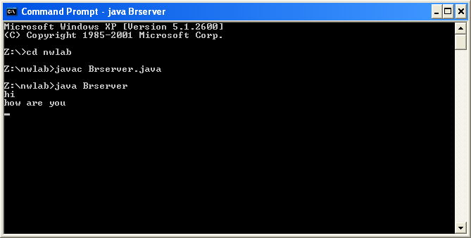

Client 1

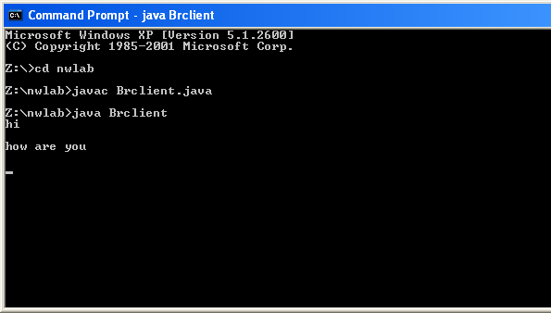

Client 2

CONCLUSION

The program to implement the broadcasting of messages was executed successfully and the result was obtained.

Program No:8
Date:15/09/10

CHAT USING A CENTRAL SERVER

PROBLEM DEFINITION

The program is to implement a chat using central server.

THEORETICAL BACKGROUND

Client-server is a computing architecture which separates a client from a server, and is almost always implemented over a computer network. Each client or server connected to a network can also be referred to as a node. The most basic type of client-server architecture employs only two types of nodes: clients and servers.There are many different types of servers; some examples include: a file server, terminal server, or mail server. Client-server architecture is intended to provide a scalable architecture, whereby each computer or process on the network is either a client or a server.

A socket is one end-point of a two-way communication link between two programs running on the network. Socket classes are used to represent the connection between a client program and a server program. Socket classes are used to represent the connection between a client program and a server program. The java.net package provides two classes, Socket and ServerSocket that implement the client side of the connection and the server side of the connection, respectively.

DatagramPacket defines several constructors. Four are described here. The first constructor specifies a buffer that will receive data, and the size of a packet. It is used for receiving data over a DatagramSocket. The second form allows you to specify an offset into the buffer at which data will be stored. The third form specifies a target address and port, which are used by a DatagramSocket to determine where the data in the packet will be sent. The fourth form transmits packets beginning at the specified offset into the data. Think of the first two forms as building an “in box,” and the second two forms as stuffing and addressing an envelope. Here are the four constructors:
DatagramPacket(byte data[ ], int size)
DatagramPacket(byte data[ ], int offset, int size)
DatagramPacket(byte data[ ], int size, InetAddress ipAddress, int port)
DatagramPacket(byte data[ ], int offset, int size, InetAddress ipAddress, int port)

ALGORITHM

Client
1. Start
2. Create the client class object that implements Runnable.
3. Read the address of the server and bind the socket to the server port.
4. Create two threads. One thread reads keyboard input and outputs it to the server. The
second thread reads input from other clients from the server and displays it.
5. Stop.

Server
1. Start
2. Create object for server class that implements Runnable.
3. Accept the client request and generate two threads for each client
4. Read input from the client through one thread and output the data to the client through
another thread.
5. Stop.

PROGRAM DEVELOPMENT

Server:

import java.net.*;
import java.io.*;

class censerver
{
DatagramSocket sock;
DatagramPacket pack;
InetAddress addr;
byte[] data;

censerver()
{
try
{
addr = addr.getByName("233.6.9.1");
sock = new DatagramSocket(9500);
}
catch(Exception e)
{
System.out.println("Error:"+e);
}
}

public void broadcast()
{
String s = "start";

try
{
do
{
data = new byte[100];
pack = new DatagramPacket(data,data.length);
sock.receive(pack);
s = new String(data);
System.out.println(s);

data = s.getBytes();
pack = new DatagramPacket(data,data.length,addr,9500);
sock.send(pack);
}while(!s.equals("stop"));

sock.close();
}
catch(Exception e)
{
System.out.println("Error:"+e);
}
}

public static void main(String args[])
{
censerver server = new censerver();

server.broadcast();
}
}

Client

import java.net.*;
import java.io.*;

class cenclient implements Runnable
{
MulticastSocket sock;
DatagramPacket pack;
InetAddress addr;
byte[] data;
BufferedReader br;

Thread tc1=new Thread(this,"send");
Thread tc2=new Thread(this,"rec");

cenclient()
{
try
{
addr = InetAddress.getByName("233.6.9.1");
sock = new MulticastSocket(9300);
sock.joinGroup(addr);

tc1.start();
tc2.start();
}
catch(Exception e)
{
System.out.println("Error:"+e);
}
}

public void run()
{
if(Thread.currentThread().getName().equals("send"))
{
try
{
send();
}
catch(Exception e)
{
System.out.println("Error:"+e);
}
}
else
{
try
{
receive();
}
catch(Exception e)
{
System.out.println("Error:"+e);
}
}

}

public void send()
{
String s = "start";

try
{
do
{
br = new BufferedReader(new InputStreamReader(System.in));
s = br.readLine();
data = s.getBytes();
pack = new DatagramPacket(data,data.length,addr,9300);
sock.send(pack);
}while(!s.equals("stop"));
}
catch(Exception e)
{
System.out.println("Error:"+e);
}
}

public void receive()
{
String s = "start";

try
{
do
{
data = new byte[100];
pack = new DatagramPacket(data,data.length);
sock.receive(pack);
s = new String(data);
System.out.println(s);
}while(!s.equals("stop"));

sock.leaveGroup(addr);
sock.close();
}
catch(Exception e)
{
System.out.println("Error:"+e);
}
}

public static void main(String args[])
{
cenclient client = new cenclient();
}
}

TESTING STRATEGIES

Case 1:

Client 1: Client 2:
Hi
Gudafternoon
Exit Hello
Bye
Stop

SUMMARY OF RESULTS

Case 1:

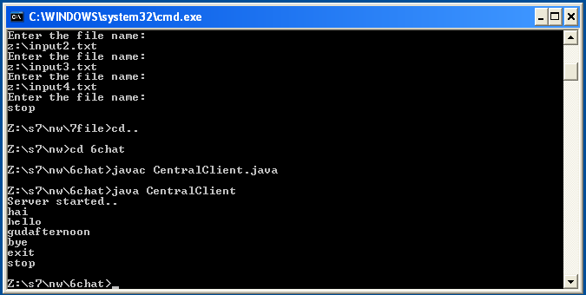

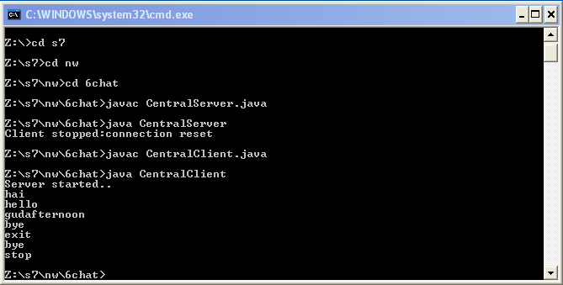

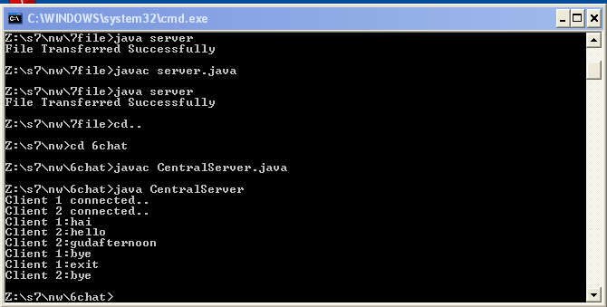

CONCLUSION

The program to implement chatting of clients using a central server was developed successfully and the result was obtained.

Program No: 09
Date: 22-09-10

FILE SERVER

PROBLEM DEFINITION

The program is to implement a File server program.

THEORETICAL BACKGROUND

In the client/server model, a file server is a computer responsible for the central storage and management of data files so that other computers on the same network can access the files. A file server allows users to share information over a network without having to physically transfer files by floppy diskette or some other external storage device. Any computer can be configured to be a host and act as a file server. In its simplest form, a file server may be an ordinary PC that handles requests for files and sends them over the network.

In a more sophisticated network, a file server might be a dedicated network-attached storage (NAS) device that also serves as a remote hard disk drive for other computers, allowing anyone on the network to store files on it as if to their own hard drive. In common parlance, the term file server refers specifically to a computer on which a user can map or mount a disk drive or directory so that the directory appears to be on the machine at which the user is sitting.

Traditionally, file and print services have been combined on the same computers due to similar computing requirements for both functions. Usually, such computers are distinct from application and database servers, which have different, usually more processor-intensive, requirements. However, as computing power increases and file serving requirements remain relatively constant, it is more common to see these functions combined on the same machine.
A file output stream is an output stream for writing data to a File or to a FileDescriptor. Whether or not a file is available or may be created depends upon the underlying platform. Some platforms, in particular, allow a file to be opened for writing by only one FileOutputStream (or other file-writing object) at a time. In such situations the constructors in this class will fail if the file involved is already open.
FileOutputStream is meant for writing streams of raw bytes such as image data. For writing streams of characters, consider using FileWriter.

A FileInputStream obtains input bytes from a file in a file system. What files are available depends on the host environment. FileInputStream is meant for reading streams of raw bytes such as image data. For reading streams of characters, consider using FileReader

The FileInputStream class creates an InputStream that you can use to read bytes from
a file. Its two most common constructors are shown here:
FileInputStream(String filepath)
FileInputStream(File fileObj)
Either can throw a FileNotFoundException. Here, filepath is the full path name of a file,
and fileObj is a File object that describes the file.

ALGORITHM

Server

1. Start
2. Create buffered reader for reading from keyboard and from input stream.
3. Create printwriter pw to write to output stream.
4. Create server socket object and listen for client request at same port number.
5. Accept client request and establish connection.
6. Read from inputstream and store it in a strig.
7. Create a file inputstream and initialize it by passing file name stored in the string.
8. Read content of file and store to another string and write it to the outputstream.
9. Stop

Client

1. Start.
2. Create buffered reader for reading from keyboard and from input stream.
3. Create printwriter pw to write to output stream.
4. Create socket object and initialize port number.
5. Accept file name from keyboard.
6. Write string to the output string.
7. Read file content from the server and store it in a string.
8. Create new file name from keyboard and store in another string
9. Create the file output stream and initialize it.
10. Write string content in file.
11. Stop

PROGRAM DEVELOPMENT

Server

import java.io.*;
import java.net.*;

class fserver
{
public static void main(String args[])
{
try
{
ServerSocket ss = new ServerSocket(6767);
Socket s = ss.accept();
FileOutputStreamfout=newFileOutputStream("C:/Users/Cyrin/S7/final.txt");

while(true)
{
int r;
DataInputStreamd= new DataInputStream(s.getInputStream());
r = d.read();

if(r!=-1)
{
fout.write(r);
}
else
{
fout.close();
s.close();
ss.close();
System.out.println("File Transferred Successfully");
System.exit(0);
}
}
}
catch(Exception e)
{
System.out.println(e);
}
}
}

Client

import java.net.*;
import java.io.*;
import java.awt.*;
import javax.swing.*;

class fclient
{
public static void main(String args[])
{
try
{
int i;
String str;

Socket s = new Socket("localhost",6767);
BufferedReaderbr=newBufferedReader(newInputStreamReader(System.in));
PrintStream pw = new PrintStream(s.getOutputStream(),true);

do
{
System.out.println("Enter the file name:");
str = br.readLine();

if(!str.equals("stop"))
{
FileInputStream fin = new FileInputStream(str);

do
{
i = fin.read();
if(i!=-1)
{
pw.write(i);
}
}while(i!=-1);

fin.close();
}
}while(!str.equals("stop"));

s.close();
}
catch(IOException e)
{
System.out.println("ERROR"+e);
}
}
}

TESTING STRATEGIES

Case 1:

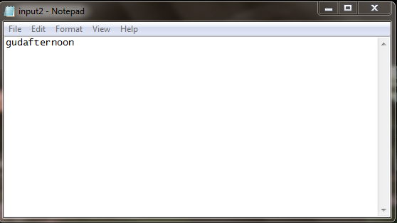

Case 2:

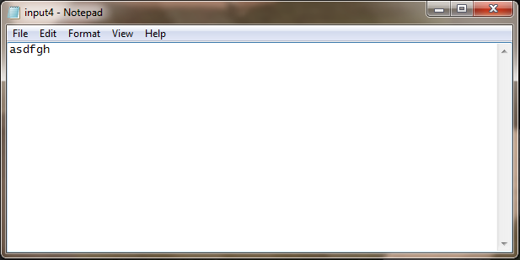

SUMMARY OF RESULTS

Case 1:

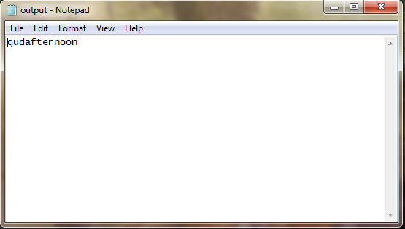

Case 2:

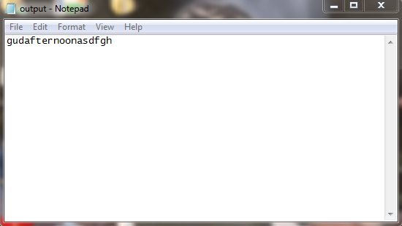

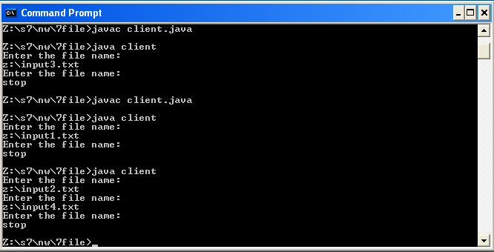

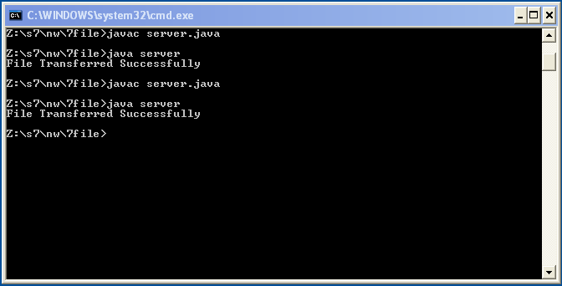

CONCLUSION

The program to implement a file server was developed successfully and the result was obtained.

Experiment No:10
Date: 28-09-2010

CLIENT TO SERVER DATA TRANSFER USING GUI

PROBLEM DEFINITION

The objective of this experiment is to implement a client to server data transfer through a graphical user interface.

THEORETICAL BACKGROUND

A graphical user interface is built of graphical elements called components. Typical components include such items as buttons, scrollbars, and text fields. Components allow the user to interact with the program and provide the user with visual feedback about the state of the program. The GUI part of the program is implemented using the java packages java.swing and java.awt.
Swing is a GUI toolkit for Java. It is one part of the Java Foundation Classes (JFC). Swing includes graphical user interface (GUI) widgets such as text boxes, buttons, split-panes, and tables. Swing widgets provide more sophisticated GUI components than the earlier Abstract Window Toolkit. Since they are written in pure Java, they run the same on all platforms. Swing supports pluggable look and feel – not by using the native platform's facilities, but by roughly emulating them. This means you can get any supported look and feel on any platform. The disadvantage of lightweight components is slower execution. The advantage is uniform behavior on all platforms.
The AWT was designed to provide a common set of tools for graphical user interface design that work on a variety of platforms. The user interface elements provided by the AWT are implemented using each platform's native GUI toolkit, thereby preserving the look and feel of each platform. This is one of the AWT's strongest points. The disadvantage of such an approach is the fact that a graphical user interface designed on one platform may look different when displayed on another platform.
Swing is a platform independent, component-oriented, extensible, customizable, configurable, loosely-coupled, light-weight UI, event dispatching, MVC GUI framework, with a single-threaded programming model, for the Java system.
The main part of a GUI program is Frame. A frame is the basic part of a GUI program, which holds the different parts together inside it. JFrame is a class inside the swing package used to create frames. It creates a standard window that has a title bar, resize corners and a menu bar. JPanel is a class inside the swing package. A panel is used to hold the different other components such as buttons, labels, textfields, text areas, scroll bars, combo box, check box etc. Another package java.awt.event is used to listen to the window and button events, such as window closing and button click.
The concepts of chat is similar to all the previous experiments except that we make use of a GUI in this experiment. we use Socket programming to achieve the chat. A socket is a software endpoint that establishes bidirectional communication between a server program and one or more client programs. The socket associates the server program with a specific hardware port on the machine where it runs, so any client program anywhere in the network with a socket associated with that same port can communicate with the server program.

ALGORITHM

Server

Step 1: Start
Step 2: Create class named gui that extends JFrame and implements interface Runnable and
action listener
Step 3: Declare required data structure and gui components
Step 4: Create server socket
Step 5: Implement frame. Add components to the container.
Step 6: Write return corresponding to the text field.
Step 7: Connect the client and request data
Step 8: Stop

Client

Step 1: Start.
Step 2: Create class named gui that extends JFrame and implements interface Runnable and
action listener
Step 3: Declare gui components and data structures necessary.
Step 4: Create socket structure.
Step 5: Implement Frame and add all components to the container.
Step 6: Write return corresponding to text field.
Step 7: Read message from server side.
Step 8: Add message to text area where all messages are displayed.
Step 9: Stop

PROGRAM DEVELOPMENT
Server:

import javax.swing.*;
import java.awt.*;
import java.net.*;
import java.io.*;
public class Server extends JFrame
{
private TextArea ta1;
private ServerSocket ss;
private Socket s;
private BufferedReader br;
private String data;
JPanel p;
Container c;
FlowLayout f;
Server()
{
setSize(200,200);
setResizable(false);
setTitle("Server Started");
setDefaultCloseOperation(JFrame.EXIT_ON_CLOSE);
f = new FlowLayout(FlowLayout.CENTER);
setLayout(f);
ta1 = new TextArea("",8,15,TextArea.SCROLLBARS_BOTH);
p = new JPanel();
p.add(ta1);
c = getContentPane();
c.add(p);}
public int getConnect()
{
try
{
ss = new ServerSocket(8000);
s = ss.accept();
return 1;
}
catch(Exception e)
{
System.out.println(e.getMessage());
return 0;
}}
public void receive()
{
try{
do{
br = new BufferedReader(new InputStreamReader(s.getInputStream()));
data = br.readLine();
if(data.equals("stop")) System.exit(0);
ta1.append(data+"\n");
}
while(true);
}
catch(Exception e)
{
System.out.println(e.getMessage());}
}
public static void main(String args[])
{
Server s = new Server();
Boolean status = true;
s.setVisible(true);
do
{
if(s.getConnect()==1)
{
s.setTitle("Connected");
status = false;
}}
while(status);
s.receive();
}}

Client:

import javax.swing.*;
import java.awt.*;
import java.awt.event.*;
import java.io.*;
import java.net.*;

public class Gui extends JFrame
{
JLabel l1;
JTextField f1;
JButton b1;
JPanel p;
Container c;
FlowLayout fl;
PrintWriter pw;
public Socket s;
InetAddress add;
public Gui() throws Exception
{
try
{
try
{
add = InetAddress.getLocalHost();
s = new Socket(add,8000);
pw = new PrintWriter(s.getOutputStream(),true);
}
catch(Exception e)
{
System.out.println(e.getMessage());
}}
catch(Exception x)
{
System.out.println(x.getMessage());
}
setSize(300,80);
setResizable(false);
setDefaultCloseOperation(JFrame.EXIT_ON_CLOSE);
setTitle("Chat using Gui");
fl = new FlowLayout(FlowLayout.LEFT);
setLayout(fl);
l1 = new JLabel("Message: ");
f1 = new JTextField("",10);
b1 = new JButton("Send");
b1.setSize(50,50);
b1.addActionListener(new ActionListener()
{
public void actionPerformed(ActionEvent e)
{
send();
}});

f1.addKeyListener(new KeyAdapter()
{
public void keyPressed(KeyEvent e)
{
if(e.getKeyCode() == e.VK_ENTER)
{
send();
}}
});
c = getContentPane();
p = new JPanel();
p.add(l1);
p.add(f1);
p.add(b1);
c.add(p);

}
public void send()

{
String s = f1.getText();
f1.setText("");
f1.requestFocus();
try
{pw.println(s);
}
catch(Exception e)
{System.out.println("Error : Server Not Connected");

}
}
public static void main(String [] args) throws Exception
{
new Gui().setVisible(true);

}
}

TESTING STRATEGIES

Test Case 1
Server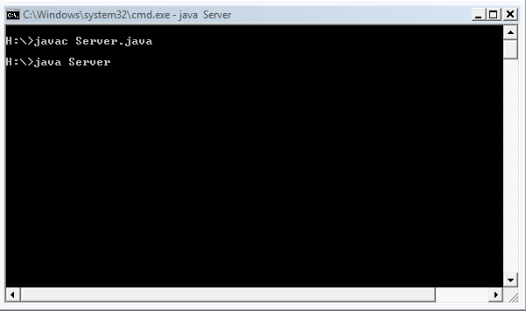
Client:
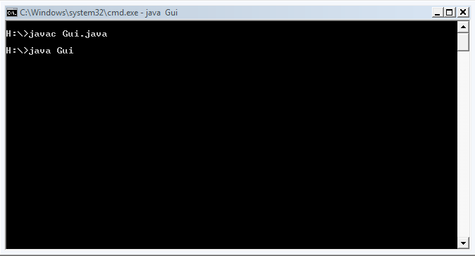

SUMMARY OF RESULTS

Case 1

Client:

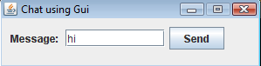

Server:

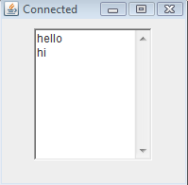

CONCLUSION

The objective of this experiment was to implement a client to server data transfer using GUI. An algorithm was developed for the same and was coded in Java. Various test cases were framed and applied. The expected results were obtained for all the test cases considered.

Program No: 11
Date: 06.10.2010

CALCULATOR

PROBLEM DEFINITION

Program to implement a calculator using graphical user interface.

THEORETICAL BACKGROUND

Client-server is a computing architecture which separates a client from a server, and is almost always implemented over a computer network. Each client or server connected to a network can also be referred to as a node. The most basic type of client-server architecture employs only two types of nodes: clients and servers.There are many different types of servers; some examples include: a file server, terminal server, or mail server. Client-server architecture is intended to provide a scalable architecture, whereby each computer or process on the network is either a client or a server.

A socket is one end-point of a two-way communication link between two programs running on the network. Socket classes are used to represent the connection between a client program and a server program. Socket classes are used to represent the connection between a client program and a server program. The java.net package provides two classes, Socket and ServerSocket that implement the client side of the connection and the server side of the connection, respectively.

A graphical user interface or GUI is a type of user interface which allows people to interact with a computer and computer-controlled devices. Instead of offering only text menus, or requiring typed commands: graphical icons, visual indicators or special graphical elements called "widgets", are presented. Often the icons are used in conjunction with text, labels or text navigation to fully represent the information and actions available to a user. The actions are usually performed through direct manipulation of the graphical elements.

BufferedReader Class provides an implementation of the abstract Reader class that buffers character data from another reader. The package of this class is java.io. The BufferedReader class provides functionality to read characters from a stream with buffering. It also provides mark and reset functionality for reading characters back and forth within a buffered limit from a sequential stream. BufferedReader has got a constructor which is overloaded and initializes a new instance of BufferedReader object. The readLine function reads the entire line from the underlying stream.

The method of writing to the console when using Java is through a PrintWriterstream. PrintWriter is one of the character-based classes. PrintWriter defines several constructors. The syntax of PrintWriter: PrintWriter(OutputStream outputStream, boolean flushOnNewline). Here, outputStream is an object of type OutputStream, and flushOnNewline controls whether Java flushes the output stream every time a newline ('\\n') character is output. If flushOnNewline is true, flushing automatically takes place. If false, flushing is not automatic. PrintWriter supports the print( ) and println( ) methods for all types including Object, to print to the underlying output stream. Thus, you can use these methods in the same way as they have been used with System.out.

ALGORITHM

Client
1. Start.
2. Create class named gui that extends JFrame and implements interface Runnable and
action listener
3. Declare gui components and data structures necessary.
4. Create socket structure.
5. Implement Frame and add all components to the container.
6. Write return corresponding to text field.
7. Read message from server side.
8. Add message on text are where all messages are displayed.
9. Stop.

Server
1. Start.
2. Create class name server that extends JFrame and implements interface Runnable and
action listener
3. Declare required data structure and GUI components like that text field text area button etc
4. Create serversocket
5. Implement frame .Add components to container.
6. Write return corresponding to text field.
7. Connect to client and request data.
8. Stop.

PROGRAM DEVELOPMENT

Server Side

import java.io.*;
import java.net.*;
public class CalcServer {
public CalcServer(){
try {
ServerSocket s = new ServerSocket(7000);
while(true){
System.out.print("waiting..");
Socket c=s.accept();
Process p=new Process(c);
p.start();
}
} catch (Exception ex) {}
}
public static void main(String args[]){
new CalcServer();
}
}
class Process extends Thread{
BufferedReader b;
PrintWriter p;
String s;
public Process(Socket c){
System.out.print("Thread object");

try {
b=new BufferedReader(new InputStreamReader(c.getInputStream()));
p = new PrintWriter(c.getOutputStream(), true);
} catch (Exception ex) {
}
}
public void run(){
try {
while(true){
s = b.readLine();
int ans=calculate(s);
System.out.print(ans);
System.out.print(" ");
p.println(ans);
}
} catch (Exception ex) {
Thread.currentThread().stop();
}
}
public int calculate(String ss){
String opnd1="",opnd2="";
char optr = 0;
int num1,num2;
for(int i=0;i<ss.length();i++){
if((ss.charAt(i)!='+')&&(ss.charAt(i)!='-')&&(ss.charAt(i)!='*')&&(ss.charAt(i)!='/')){
opnd1=opnd1+ss.charAt(i);
}
else{
optr=ss.charAt(i);
for(int j=i+1;j<ss.length();j++){
opnd2=opnd2+ss.charAt(j);
}
break;
}
}
num1=Integer.parseInt(opnd1);
num2=Integer.parseInt(opnd2);
switch(optr){
case '+': return num1+num2;
case '-': return num1-num2;
case '*': return num1*num2;
case '/': return num1/num2;
}
return 0;
}}

Client Side

import java.awt.*;
import javax.swing.*;
import java.io.*;
import java.net.*;
import java.awt.event.*;
class CalcClient{
public static void main(String args[]){
new Connection();
new Calculator();
}
}
class Connection{
Socket c;
public static PrintWriter p;
public static BufferedReader b;
public Connection(){
try{
c=new Socket("localhost",7000);
p=new PrintWriter(c.getOutputStream(),true);
b=new BufferedReader(new InputStreamReader(c.getInputStream()));
}
catch(Exception e)
{
System.out.println("\nServer not found");
System.exit(0);
}
}

}
class Calculator extends JFrame implements ActionListener,WindowListener{
JButton[] b;
JButton badd,bsub,bmul,bdiv,beq;
JTextField display;
int i,f=0;
String s="",qs="";
public Calculator(){
super("Calculator");
Container c=this.getContentPane();
display=new JTextField(12);
display.setEditable(false);
display.setBackground(Color.WHITE);
b=new JButton[10];
for(i=0;i<10;i++){
b[i]=new JButton(Integer.toString(i));
b[i].addActionListener(this);
}
badd=new JButton("+");
bsub=new JButton("-");
bmul=new JButton("*");
bdiv=new JButton("/");
beq=new JButton("=");
badd.addActionListener(this);
bsub.addActionListener(this);
bmul.addActionListener(this);
bdiv.addActionListener(this);
beq.addActionListener(this);
BorderLayout bl=new BorderLayout();
bl.setVgap(10);
c.setLayout(bl);
c.add(display,BorderLayout.NORTH);
JPanel p=new JPanel();
c.setBackground(Color.GRAY);
p.setBackground(Color.GRAY);
c.add(p,BorderLayout.CENTER);
c.add(new JLabel(" "),BorderLayout.WEST);
GridLayout g=new GridLayout(5,3);
g.setVgap(5);
g.setHgap(5);
p.setLayout(g);
for(i=0;i<10;i++){
p.add(b[i]);
}
p.add(badd);
p.add(bsub);
p.add(bmul);
p.add(bdiv);
p.add(beq);
new Thread(){
public void run(){
String sp;
try {
while(true){
sp = Connection.b.readLine();
display.setText(sp);
}
} catch (IOException ex) {
}
}
}.start();
setSize(180,225);
setResizable(false);
setLocation(500,400);
setDefaultCloseOperation(JFrame.EXIT_ON_CLOSE);
setVisible(true);
}
public void actionPerformed(ActionEvent e){
if(f==1){
s="";
qs="";
f=0;
}
JButton k=(JButton)e.getSource();
String ss=k.getText();
if(ss.equals("+")||ss.equals("-")||ss.equals("*")||ss.equals("/")){
qs=qs+ss;
s="";
}
else if(ss.equals("=")){
Connection.p.println(qs);
f=1;
}
else{
s=s+ss;
qs=qs+ss;
display.setText(s);
}
}
public void windowOpened(WindowEvent e) { }
public void windowClosing(WindowEvent e) {
Connection.p.println("exit");
}
public void windowClosed(WindowEvent e) {}
public void windowIconified(WindowEvent e) {}
public void windowDeiconified(WindowEvent e) {}
public void windowActivated(WindowEvent e) {}
public void windowDeactivated(WindowEvent e) {}
}

TESTING STRATEGIES AND SUMMARY OF RESULTS

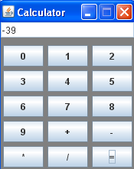

Server Side

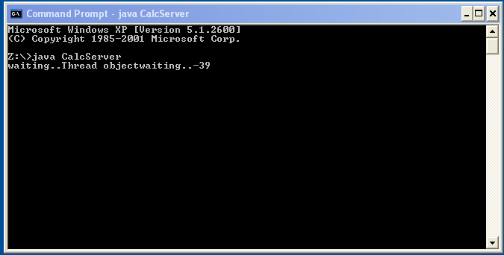

Client Side

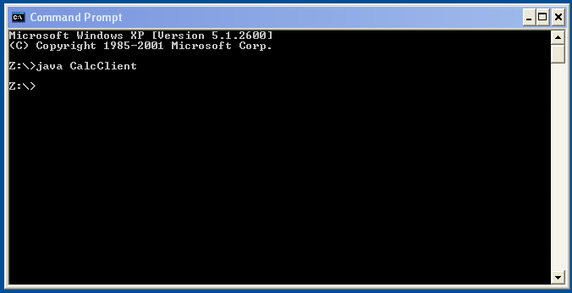

CONCLUSION
Java program to implement calculator using GUI was written, executed and output verified.

Program No: 12
Date: 06-10-2010

ITERATIVE SERVER

PROBLEM DEFINITION

Program to implement an iterative server providing multiple services according to the request made by the client. The services are:
a) Echo service
b) Date and time service

THEORETICAL BACKGROUND

Iterative Server is the simplest form of server where a server process serves one client and after completing first request then it takes request from another client. Meanwhile another client keeps waiting. The system calls for establishing a connection are somewhat different for the client and the server, but both involve the basic construct of a socket. The two processes each establish their own sockets. The steps involved in establishing a socket on the client side are as follows:
1. Create a socket
2. Connect the socket to the address of the server
3. Send and receive data.

The steps involved in establishing a socket on the server side are as follows:
1. Create a socket
2. Bind the socket to an address.
3. Listen for connections.
4. Accept a connection with the accept() system call. This call typically blocks until a client connects with the server.
5. Send and receive data.

BufferedReader Class provides an implementation of the abstract Reader class that buffers character data from another reader. The package of this class is java.io. The BufferedReader class provides functionality to read characters from a stream with buffering. It also provides mark and reset functionality for reading characters back and forth within a buffered limit from a sequential stream. BufferedReader has got a constructor which is overloaded and initializes a new instance of BufferedReader object. The readLine function reads the entire line from the underlying stream.

In an echo server the data send from the client to the server is sent back to the client by the server. The data is entered through the keyboard by the client is written to the output stream of the client using object of the Socket class which has been used to establish connection with the server by specifying the server and the port number. This is read from the InputStream of the server. The server writes the data it has read into the OutputStream of the socket using PrintWriter object. This is read by the client from its input stream and is displayed.

ALGORITHM

Server
Step 1: Start
Step 2: Create the server Socket and listen for a client request to a particular port number.
Step 3: Get choice from client using BufferedReader
Step 4: (a) If choice=1, read data to be echoed and echo it to client using PrintWriter
(b) If choice=2, get the present date, time and pass it to client
(c) Else print wrong choice
Step 5: Stop

Client
Step 1: Start
Step 2: Create the Socket
Step 3: Send request to the server. For this, we need to specify the IP address of the server along with the port number.
Step 3: Read choice of service required using BufferedReader and pass the choice to server using PrintWriter
Step 4: (a) If choice=1, read data, pass it to server and read echoed data from server using BufferedReader
(b)If choice=2, read the present date, time from server using BufferedReader
Step 5: Stop

PROGRAM DEVELOPMENT

Server

import java.io.*;
import java.net.*;
import java.util.*;
public class Iserver
{
public static void main(String args[])
{
Socket c;
ServerSocket s;
BufferedReader b1,b2;
PrintWriter p1,p2;
String str1,str2,str3;
try
{
s=new ServerSocket(8000);
while(true)
{
c=s.accept();
b1=new BufferedReader(new InputStreamReader(c.getInputStream()));
p1=new PrintWriter(c.getOutputStream(),true);
String str=b1.readLine();
System.out.println("Selected choice is"+str);
if(str.equals("1"))
{
p1.println("Connected with server...Enter data to echo");
str1=b1.readLine();
p1.println(str1);
}
else if(str.equals("2"))
{
Date date=new Date();
p1.println(date.toString());
}
else
{
p1.println("Error");
}
c.close();
}
}
catch(Exception e)
{
}
}
}

Client

import java.io.*;
import java.net.*;
public class Iclient
{
public static void main(String args[])
{
Socket sc;
try
{
sc=new Socket("localhost",8000);
BufferedReader b1=new BufferedReader(new InputStreamReader(System.in));
BufferedReader b2=new BufferedReader(new InputStreamReader(sc.getInputStream()));
PrintWriter p=new PrintWriter(sc.getOutputStream(),true);
System.out.println("1.Echo Server");
System.out.println("2.Date and Time Service");
System.out.println("Enter Your Choice");
String st=b1.readLine();
p.println(st);
if(st.equals("1"))
{
String s1=b2.readLine();
System.out.println(s1);
String s2=b1.readLine();
p.println(s2);
s1=b2.readLine();
System.out.println(s1);
}
else if(st.equals("2"))
{
String s3=b2.readLine();
System.out.println("Current date and Time is:"+s3);
}
else
{
String s4=b2.readLine();
System.out.println(s4);
}
}
catch(Exception e) {
}
}
}

TESTING STRATEGIES

Test case 1:

When first client requested for echo service to the server

When second client requested for date and time service to the server

SUMMARY OF RESULTS

Case 1:
When first client requested for echo service to the server

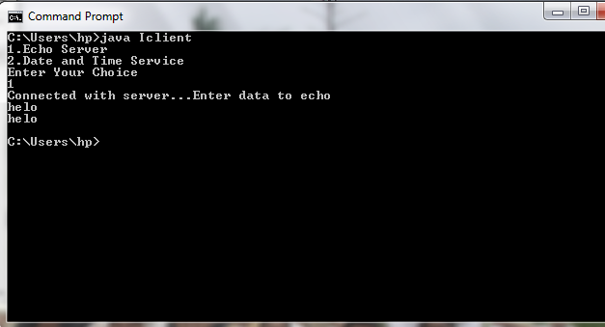

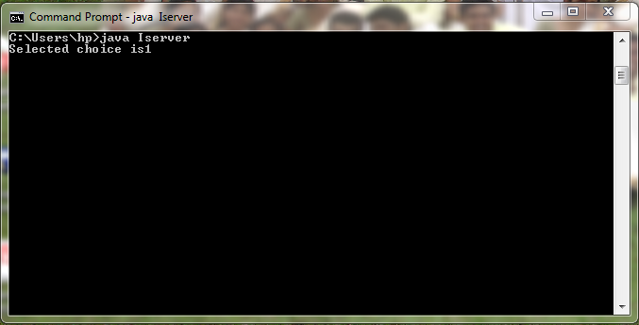

When second client requested for date and time service to the server

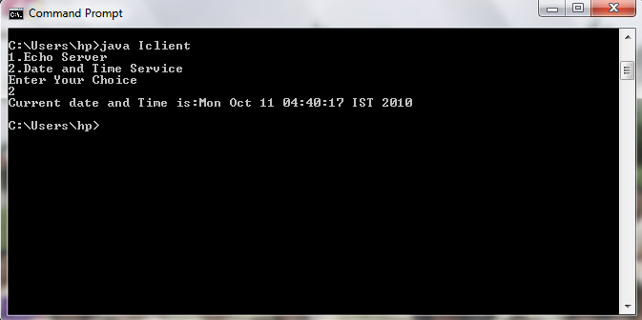

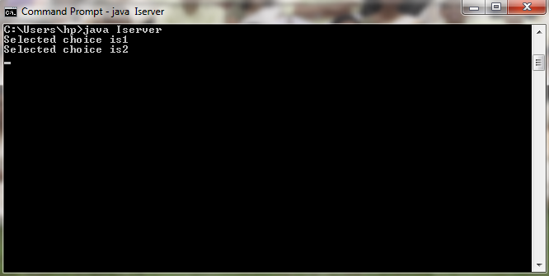

CONCLUSION

Program to implement an iterative server providing multiple services according to the request made by the client was developed and results were verified.

Program No: 13
Date: 06.10.2010

REMOTE METHOD INVOCATION

PROBLEM DEFINITION

Program to implement arithmetic operations using RMI system which allows an object running in one JVM to invoke methods on an object running in another JVM.

THEORETICAL BACKGROUND

The Java Remote Method Invocation (RMI) system allows an object running in one Java virtual machine (JVM) to invoke methods on an object running in another JVM. RMI provides for remote communication between programs written in the Java programming language. Java RMI is a Java application programming interface for performing the object equivalent of remote procedure calls.

RMI structure

A client is supplied with the interface of methods available from the remote server and all the implementation is left to the server side. The details of implementing the remote methods are abstracted from the client software. The client and server of an RMI system are connected through a layered connection, operated by the RMI subsystem of the two virtual machines involved.

The stubs and skeletons provide additional abstraction for the Java developer, once an RMI system is established. The code may be written as if all methods and objects are local to the client. The remote reference layer handles reference variables to remote objects, using the Transport layer's TCP/IP connection to the server. A client requests a reference to an object from the server using the stub on the client side. The server gets the request from a skeleton on the server side. Between the two is the remote reference layer, which negotiates the requests by converting objects into portable form across the network. This conversion is called marshalling.

Steps in implementing an RMI system

1) Define and compile the four files needed for the system, namely:-
(i) ServerIntf.java:- defines the remote interface provided by the server. All the remote interfaces must extend the Remote interface, which is part of java.rmi
(ii) ServerImpl.java, implements the remote interface. All remote methods must extend the UniCastRemoteObject, which provides the functionality that is needed to make objects available from remote machines
(iii) Server.java:- contains the main program for the server machine. Its primary function is to update the RMI registry on that machine. This is done by using the rebind() method of the naming class
(iv) Client.java, implements the client side of this distributed application. The program invokes the lookup() method in the naming class

2) Generate the Stub and Skeleton

The stub is a java object that resides on the client machine. Its function is to present the same interfaces as the remote server. The skeleton is a java object that resides on the server machine.
To generate the stubs and the skeleton, we use the RMI compiler, which is invoked from the command line
rmic ServerImpl

3) Install the files on the client and the server machines

Copy the client class, Implementation stub class and the Interface class on the client machine and copy the Interface class, Implementation class, Implementation skeleton class, Implementation stub class and Server class on the server machine.

4) Start the rmi registry on the server machine

start rmiregistry

5) Start the server

java Server

6) Start the client

java Client

ALGORITHM

Step 1: Start
Step 2: Define the client which takes the numbers as command line arguments.
Step 3: Server url=”rmi://+127.0.0.1+”/AddServer”, call Naming.lookup().
Step 4: Create an object of server interface class.
Step 5: Convert the numbers specified as arguments to integer from string.
Step 6: Call the add function of server interface class passing the numbers as arguments.
Step 7: Declare the add function in the server interface.
Step 8: Define the add function in the server implementation class.
Step 9: Function add:- return the sum of numbers passed as arguments.
Step10: Define the server which creates an object of server implementation, call Naming.rebind().
Step 11: Print the sum of the two numbers.
Step 12: Stop.

PROGRAM DEVELOPMENT

Server
import java.net.*;
import java.rmi.*;
public class AddServer
{
public static void main(String arg[])
{
try
{
AddServerImpl addServerImpl = new AddServerImpl();
Naming.rebind("AddServer",addServerImpl);
}
catch(Exception e){
System.out.println("Exception :"+ e);
}
}
}

Server Implementation
import java.rmi.*;
import java.rmi.server.*;
public class AddServerImpl extends UnicastRemoteObject implements AddServerIntf
{
public AddServerImpl() throws RemoteException
{
}
public double add(double d1,double d2)throws RemoteException
{
return d1+d2;
}
public double sub(double d1,double d2)throws RemoteException
{
return d1-d2;
}
public double mul(double d1,double d2)throws RemoteException
{
return d1*d2;
}
public double div(double d1,double d2)throws RemoteException
{
return d1/d2;
}
}

Server Interface
import java.rmi.*;
public interface AddServerIntf extends Remote
{
double add(double d1,double d2)throws RemoteException;
double sub(double d1,double d2)throws RemoteException;
double mul(double d1,double d2)throws RemoteException;
double div(double d1,double d2)throws RemoteException;
}

Client
import java.io.*;
import java.rmi.*;
public class AddClient
{
public static void main(String args[])
{
try
{
int ch;
String addServerURL="rmi://"+args[0]+"/AddServer";
AddServerIntf addServerIntf = (AddServerIntf)Naming.lookup(addServerURL);
System.out.println("The first number is:"+ args[1]);
double d1=Double.valueOf(args[1]).doubleValue();
System.out.println("The second number is:"+ args[2]);
double d2=Double.valueOf(args[2]).doubleValue();
System.out.println("press 1 to add,2 to subtract, 3 to multiply, 4 to divide\n");
BufferedReader br=new BufferedReader(new InputStreamReader(System.in));
String number =br.readLine();
ch = Integer.parseInt(number);
switch(ch)
{
case 1:
System.out.println("The result is: "+addServerIntf.add(d1,d2));
break;
case 2:
System.out.println("The result is: "+addServerIntf.sub(d1,d2));
break;
case 3:
System.out.println("The result is: "+addServerIntf.mul(d1,d2));
break;
case 4:
System.out.println("The result is: "+addServerIntf.div(d1,d2));
break;
}
}
catch(Exception e)
{
System.out.println("Exception: "+e);
}
}
}

TESTING STRATEGIES AND SUMMARY OF RESULTS

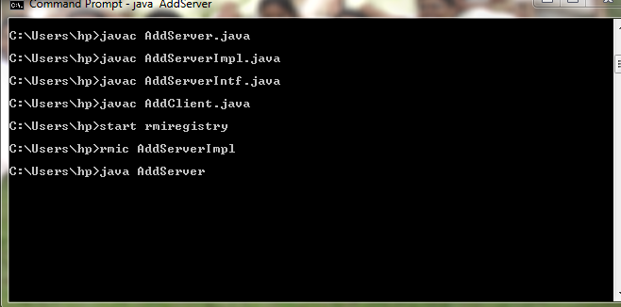

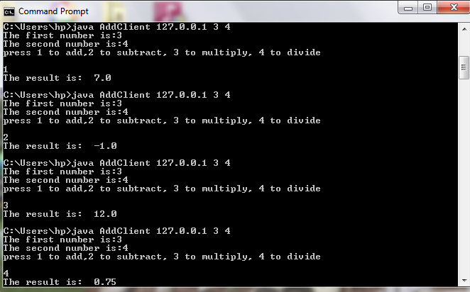

CONCLUSION

Program to implement arithmetic operations on numbers using remote method invocation was developed and results were verified.

